FUNTIONAL SPECIFICATION

WMS ONLINE

Table of contents
- Process Flow
  - Flow Diagram
- Specifications
  - General specifications
    - Functional
    - User Interface
  - Masters
    - Party Master
    - Product Master
    - Location Master
    - UOM Master
    - UOM Conversion Master
    - Quick Code
    - Reason Code Master
  - Warehouse Transaction
    - Adjustment
    - Movement
    - Stock Control
    - Stock Release
  - Inbound
    - Receipt
    - Confirm SRV
  - Outbound
    - Issue
  - Enquiry
    - Location Details
    - Location Cost
    - Product details
  - Stock Take
    - Cycle count
  - Reports
  - System Admin
    - System Admin
    - Ware house

Process flow

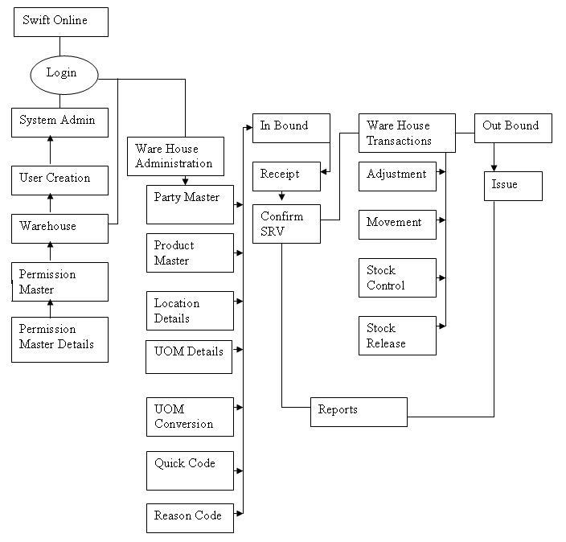

Specifications

General specifications

Functional
Web based system | For connectivity between branches.
Data entry is quick and reliable | User could key in the key contract details through the user friendly interfaces.
Operating System | System should be able to operate with Windows 98 and Internet Explorer browser 6.0 and above. Minimum RAM configuration would be 128MB.
Interfacing with other systems | Capable of interfacing with other transactional systems to avoid data duplication.

User interface
Minimal keystrokes to access screens | Quick switching between screens using user friendly menus.
Reports | Reports for users on the basis of list given in grid (Product status, Adjustment details etc)

Masters:

Party Master:

Information Captured | - Party Code  - Party Name  - Country (Drop down list box)  - City (Drop down list box)  - Address  - Fax Number  - Telephone number  - Postal Code  - Contact Name  - Credit Limit  - Payment Terms  - Business Hour  - Party service Level  - Order Priority  - Services Provided (Client, Forwarder…)
Description | Store the details of Party and business. In this system user add new party details, Edit a record and delete a record at anytime.
Events | ADD,EDIT,VIEW and DELETE

Product Master:

Information Captured | - Client Code (Drop down list box, should capture from party master)  - Product Code  - Product Name  - Product description  - Product Category  - UOM (Drop down list box)  - Product Dimensions ( Length, Width, height )  - Serial Number  - Expiry date.  - Storage Form.  - Location Area
Description | Store the details of product. In this system user could add new product details, Edit the record and delete a record at any time.
Events | ADD,EDIT,VIEW and DELETE

Location Master

Information Captured | - Location No  - Warehouse Name  - Location area (Drop down list box)  - Location type (Drop down list box)  - Location section (Drop down list box)  - Bin Number  - Maximum Volume  - Minimum Volume  - Location condition  - Location Indicator  - Currency (Drop down list box)  - Location cost
Description | It is used for adding and designing new locations. The warehouse will be fixed as per the user login. Edit the record and delete a record at any time.
Events | ADD,EDIT,VIEW and DELETE

Unit of Measurement (UOM) Master:

Information Captured | - UOM Code  - Description
Description | Store the details of UOM type and description for the product, In this system user added new UOM details, Edit a record and delete a record at any time.
Events | ADD,EDIT,VIEW and DELETE

Unit of Measurement Conversion:

Information Captured | - Client Code  - Product No  - From UOM  - Conversion rate.  - To UOM
Events | ADD,EDIT,VIEW and DELETE

Quick Code:

Information Captured | - Type  - Type code  - Type Description
Description | User could add any number of quick codes for different types selected. E.g. Country, city, Location type, shipment type etc.
Events | ADD,EDIT,DELETE and DELETE

Reason Code Master:

Information Captured | - Reason Code  - Reason type  - Description
Description | Store the details of reason for mismatch with physical stock. In this system user could add any type of reason details, Edit a record and delete a record at any time.
Events | ADD,EDIT,DELETE and DELETE

Warehouse Transaction:

Adjustment:

Client Code | Client code keyed in the party master will be displayed in combo box to select.
Adjustment Date | Always shows the system date
Adjustment number | System could automatically generate a unique Auto generation number for each entry. The Adjustment number should be preceded with the first 3 letters of client code, ‘ADJ’ and auto generation number for a new adjustment entry.
Remarks | Remarks should not be a mandatory field. It should have user information regarding that particular adjustment no.
Reference No | Reference No field is not mandatory one.
Save | For Saving the record
Adjustment View | It should be highlighted only after saving the record. Here we could load a location by selecting a product. User could select which product can be adjusted and enter the adjustment quantity, either add quantity or minus quantity, then confirm this adjustment.

Movement:

Client Code | Client code keyed in the party master will be displayed in combo box to select.
Movement Date | Always shows the systems date
Movement number | System should automatically generate a unique Auto generated number for each entry. The Movement number should be preceded with first 3 letters of client code, ‘MOV’ and auto generation number for a new Movement Entry.
Remarks | Remarks should not be a mandatory field. It should have user information regarding that particular Movement number.
Reference No | Reference number field is not mandatory one.
Save | For Saving the record
Movement View | It should be highlighted only after saving the record. The movement of Product from one location to another should be possible.

Stock Control:
Client Code | Client code keyed in the party master should be displayed in combo box to select.
Stock Control Date | User should select the date.
Stock Control number | System should automatically generate a unique Auto generation number for each entry. The Stock Control number should be preceded by first 3 letters of client code, ‘STC’ and auto generation number for a new Stock Control Entry.
Remarks | Remarks are not mandatory field. It should have user information regarding that particular Stock Control number
Reference No | Reference No should not be a mandatory filed
Save | For Saving the record
Stock Control View | It should be highlighted only after saving the record. This is to hold the remaining stock if necessary. So system should not allow the outbound for that remaining stock.

Stock Release:
Search | For Filtering the records on the basis of date and Text field
Select | Records could be selected from the grid. This is for releasing the stock control on a product.

In Bound

Receipt

Client Code | Client code keyed in the party master should be displayed in combo box to select.
Grn Date | Date selection from Calendar popup menu.
Grn No | System should automatically generate a unique GRN number for each receipt.
PO No | Key in the PO No (The customer wise PO order no)
Invoice No | Type the Invoice No, Duplication should not be allowed
Transport Mode | There should be four scopes of Transport modes. They are Air, Sea, Local and Self. The user could select any one of the transport based on the customers requirement.
Forwarder Code | Forwarder code keyed in the party master should be displayed in combo box to select.
Supplier Code | Supplier keyed in the party master should be displayed in combo box to select.
RV NO | System should automatically generate a unique Auto generated number for each entry. The RV number should be preceded with first 2 letters of client code, 'CH-RV1' and auto generated number for a new RV NO entry.
Status | System should automatically generate a unique RV number
Remarks | Goods receipt details
Note:
While selecting the save, it would get only added to the Header of receipts and then should click the Add Button to show the detailed fields to enter the product details. The detailed fields are shown below:
Product no | Product no in the product master should be displayed in combo box to select.
Expiry Date | Expiry date should be picked up from the product master
UOM | System should automatically show the UOM of that Particular product for each receipt.
Status | System should automatically show the status of that Particular product for each receipt.
Expected Qty | This should not be a mandatory field.
Delivery Qty | Total delivered quantity should be entered here
Accepted Qty | Accepted quantity should be entered here
Rejected Qty | Rejected quantity should be entered here
Outstanding Qty | Pending quantities should be entered here
Short (+) or (-) | This should not be a mandatory field. The total number of Shortage or excess should be entered here.
Remarks | This should not be a mandatory field. Particulars of product details could be entered if necessary.
Note:-
The sum of Accepted qty, Rejected qty and outstanding qty should be Equal to sum of Delivered quantity. While selecting the save button in the product details, If selected product have serial no, then enter the serial no for all products. If it is not in the serial no product, then select Confirm GRN button. Product Details should not be altered after confirmation is done.

Confirm SRV

Client Code | Client code keyed in the party master should be displayed in combo box to select.
RV NO | RV No for the client selected should come in drop down list to select.
Date | The Date should be system current date
Note: - while selecting the add button, its should show the Details such as Product number, receipt quantity, available quantity for BIN IN, location number, Client Code and Quantity Bin In . Here we should select the type of the product no, receipt quantity, quantity available for bin, Location no, client and qty binned. If product have serial no we should select the serial no. then save details of the Confirmed SRV

Out Bound

Issue

Client Code | Client code keyed in the party master should be displayed in combo box to select.
Order No | Order No should be typed here.
Order Date | Date selection from Calendar popup menu.
Issue No | While saving the Header details of the issue, System should automatically generate the issue no
Issue Date | Date selection from Calendar popup menu. Issue date should be greater or equal to order date.
Customer Po | User should be able to enter the Customer PO number
Consignee Code | Consignee code should be shown in drop down list box to select.
Forwarder code | Forwarder code should be shown in drop down list box to select.
Shipment type | Shipment type keyed in the Quick code master should be displayed in combo box to select.
Movement type | Movement type keyed in the Quick code master should be displayed in combo box to select.
Status | System should automatically show the status of that Particular product for each Issue.
Note:
While selecting the save, it would get only added to the Header of Issues and then should click the Add Button to show the detailed fields to enter the Issue details. The detailed fields are shown below:
Details
Product No | Product no in the Receipt should be displayed in combo box to select.
Issue price | This should not be a mandatory field. User could be able to enter the issue price
Discount price | This should not be a mandatory field. User could be able to enter the discount price
Location No | Should be able to Select the particular product of which location is binned
Product disc | This should not be a mandatory field. User could be able to enter the product description.
UOM | Automatically system should show the uom code
Order Qty | The number of products ordered should be entered here
Issue Qty | The number of products issued should be entered here
Total Issue price | This should not be a mandatory field. It should calculate total price if issue price is given
Location Qty | System should automatically show the status of that particular product binned in that location
Note:
While selecting the save button in the product details, If selected product have serial no, then enter the serial no for all products. If it is not in the serial no product, then select Confirm Issue button. Issue Details should not be altered after confirmation is done.

Enquiry:

Location Details:
Search | For Filtering the records on the basis of date and Text field
Purpose | It contains details about locations. That is Location Area, Location Type and bin no etc.

Location Cost:
Search | For Filtering the records on the basis of date and Text field
Purpose | It should explain details about location cost, Maximum capacity of the location and minimum quantity of the Location.

Product Details:
Search | For Filtering the records on the basis of date and Text field
Purpose | The numbers of products are available in particular location

Stock Take:

Cycle Count:

Client Code | Client code keyed in the party master should be displayed in combo box to select.
Cycle count Date | Date selection from Calendar popup menu.
Reference No | This should not be a mandatory field. User should be able to enter the reference number for a particular cycle count
Cycle count No | System should generate the unique count no
Status | Status should be set by the system. Before confirmation it should be open. After confirmation status should be changed to close.
Remarks | This should not be a mandatory field. User should be able to enter the remarks for a particular cycle count
Search Stock | After clicking save button, system should show the location and product quantity which can be further selected for physical and system stock adjustment
Stock | User should be able to key in actual physical stock details
Mark | Should lock all the transaction for the locations and product selected here.
Update | Should save all entered physical stock details
Export | Should export the location and stock report in excel
Confirm Cycle Count | Should assign physical stock as system stock.

Reports:

Product Location | This Report should show Location wise Product quantity in a particular warehouse.
Stock Status | This Report should show the entire product’s stock quantity for the particular client.
Receipt Details | This should show what are all the products received from the different customers by client wise, Product wise and GRN no wise.
Issue Details | This should show what are all the products delivered from the different customers by client wise, Product wise and GRN no wise. It contains issue no, issue date, issue product code and no of quantity issued.
GRA List | This should show list of products received from various customer
Delivery Note | It should show list of products issued from warehouse for various customer
Adjustment Details | This Report should show what product is adjusted and also should show the adjustment no, date, adjustment location and adjustment quantity for particular client.
Movement Details | This Report should show what product is moved and also the movement no, date, movement location and movement quantity for particular client.
Stock Control | This should show displays the stock control details for the particular product
Stock Take Details | It should show the difference between physical stock and systems stock
Note:
Stock Take is used for comparing the system stock details vs. actual physical stock. Finally the actual physical stock details should be updated in the system to make the inventory 100% accurate.

System Admin

System Admin

User creation
Username | New user’ should be added in this field
Password | Password should be given for every new user
Confirm Password | Confirm Password must be given for every new user
Warehouse ID | Warehouse ID entered in ware house admin module should come in combo box to select
Permission | Permission should be displayed in combo box to select.
Email-id | Text box to be given for entering email-id
Expiry Date | Expiry date must should be given
Account Disabled | Using this option we could disable the user accounts.
Locked Out | Using this locked out we could lock the user expiry days
Note:
While saving the user ‘s account, it should create a username

Warehouse

Warehouse ID | System should automatically generate the ID
Warehouse name | Text box to enter the warehouse name
Warehouse address | This should not be a mandatory field. Text box to be given to key in address.
Warehouse  Description | This should not be a mandatory field. Text box to be given to key in description
Note:
While saving the Warehouse it should create a new warehouse ID

